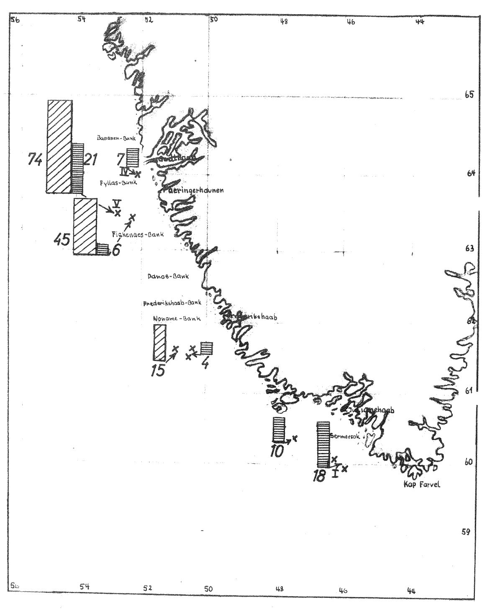
Columns indicate catches of cod (wide hatched), and redfish (narrow hatched); numbers refer to baskets (50kg) of fish caught after trawling for ½ hour

